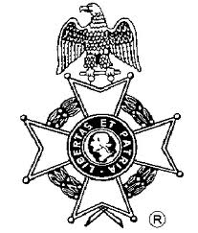
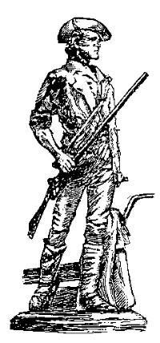
Keyhole To History Worksheet
Gov. Isaac Shelby Chapter, Sons of the American Revolution
Name: ___________________________________ Grade: ___________
Organization/School: ________________________________________
Leader/Teacher: ________________________________________
Mailing Address: ____________________________________________
Question | Answer
- Why did the Indians think George Washington was protected by the ‘great spirit’?
2. What famous phrase was first used in reference to the Stamp Act?
3. What did the local residents do to the Revenue Schooner Gaspee?
- The Boston Tea Party occurred due to what act issued by the British?
5. Which occurred first, the Boston Port Bill or the Boston Tea Party?
- The cargo on the Sloop America is the product of what American tradition?
- What bill inspired the supplies to be sent to Boston from upper Massachusetts?
8. Who did George Washington marry in the year 1759? (first and last name)
9. By what name was William Alexander better known?
10. The territory in which the Green Mountain Boys lived is now known by what name?
11. What college did the Jesuit priest John Carroll establish?
12. Name a major battle in which Lt. Colonel Henry Lee fought?
13. In what year did Washington, DC become the capital of the United States?
14. Where is America’s first planetarium located?
15. Rufus Putnam was the first Brigadier General in charge of what organization?
16. John Randolph is believed to be a descendent of what famous Indian?
17. What was Francis Marion’s nickname?
18. What college had its library burned by the British?
19. Name three famous foreign officers that volunteered to assist the American Continental Army?
20. What British officer did Governor Rutledge accuse of barbaric acts?
21. Where was General Lee headed when he was captured and why was he headed there?
22. What did John Fitch do on the Delaware River in 1787?
23. What was the name of the independent republic that later became part of the Commonwealth of Kentucky?
24. Where did the British troops go after the Battle of Lexington in Massachusetts?
25. Who were the two American commanders that captured Fort Ticonderoga?
26. What two things did the North Carolinians do to sabotage the Moores Creek Bridge?
27. Name the three islands where forts were built to protect Charleston, South Carolina?
- Name one of the first major battles after the Declaration of Independence was signed?
- What saved General Washington from total defeat at the Battle of Long Island?
- The loss of what two forts led Washington to retreat from New York?
- What prevented half of Washington’s army from attacking the Hessians at Trenton, New Jersey?
- How did the British Scouts inadvertently hurt the British Army?
- Where was the Battle of Bennington fought?
- The Battle of Brandywine was along the border of which two states?
- What did the British remove from their firearms so they could sneak up on the Americans?
- What two British generals would not help Burgoyne at the Battle of Saratoga?
- What British general captured Philadelphia?
- What was the first foreign country to salute the American Flag?
39. Which two British generals thought they could capture the Marquis de La Fayette at Barren Hill, Pennsylvania?
40. What stopped the battle between the French and English at Newport, Rhode Island?
41. Who was appointed to retake Stony Point in the year 1779?
42. Who were the British and American commanders at the Battle of Guilford Courthouse?
43. Who freed Augusta, Georgia from the British in 1781?
44. What was Captain Burrows doing when he heard about the British attack?
45. Where was the last major battle in the south during the American Revolution?
46. What was the name of the last major battle of the American Revolution?
47. How long did the siege of Yorktown last?
48. The last naval battle of the Revolutionary War was fought off the coast of what state?
49. Who do most historians agree designed the first American stars and stripes flag?
50. On what date did the last delegate sign the Declaration of Independence?
- List three things the Articles of Confederation provided the government power to do?
52. What term was used to describe the practice of private vessels capturing English trading vessels?

